Zoom Volunteer Meeting Tuesday 11 January 2022 from 10:00 to 12:00
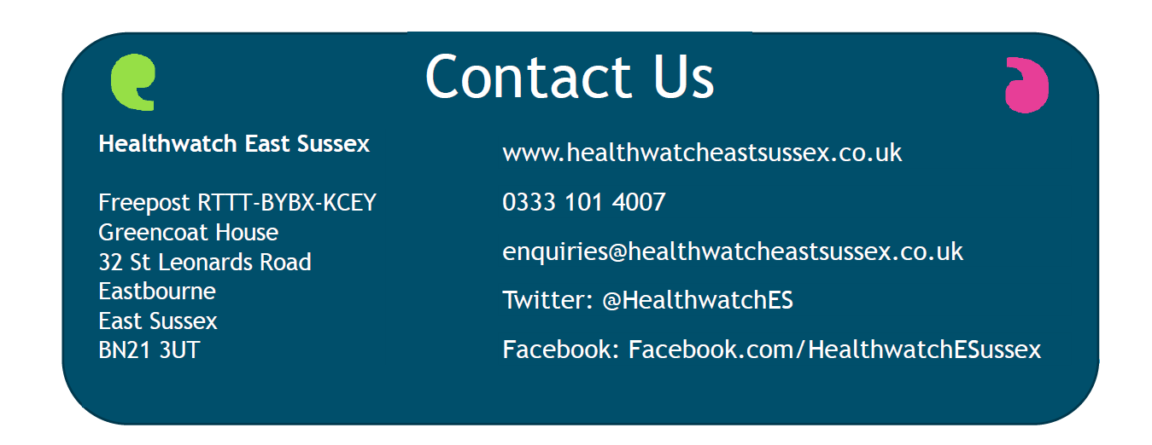
Present
Volunteers: Gwladys Mabb (Eastbourne), Jane Gorringe (Pevensey), Chris Marks (Polegate), Alan Keys (Uckfield), Phil Hale (Polegate), Linda Pugsley (Buxted), John Curry (Bexhill), Beth Simons (Heathfield), Tony Moore (Winchelsea), Cecile Stheeman (Eastbourne), Paula Cohen (Lewes), Rosemary Boucherat (Rye) and Marilyn Eveleigh (Crowborough)
Healthwatch East Sussex Staff- Elizabeth Mackie (EM), Volunteer and Community Liaison Manager and Sue Wells (SW), Administrator

Board – Vanessa Taylor and Roger Sweetman

Apologies – Edward Peasgood, (EP) Youth Participation Worker and Keith Stevens

Update on recent projects
Thank you to all those that have been involved in the recent projects – checking of GP websites and out of hours messages and access to Dentists for NHS patients. We are just putting together all the information and aim to have reports ready from both projects sin the near future.
Hospital Discharge Report – pleased to report that this has been agreed and is on our website. The report identifies 11 recommendations for East Sussex Healthcare NHS Trust who run the hospitals that patients were discharged from, NHS Commissioners who contract local GPs and Healthwatch. The focus of these is embedding the learning with a view to improving the experience for patients before, during and after discharge. EM to invite East Sussex Healthcare NHS Trust to a meeting to see where they are with the recommendations and why the report took so long to be agreed
HW Mobilisation Plan and Workplan

EM explained that all of our work is underpinned by HW England Guide to running a Healthwatch, copies can be found here. The guide explains the statutory requirements for Healthwatch and sets out good governance principles when it comes to delivering a Healthwatch service. The guide aims to provide information on the key areas of focus, recommended best practice, as well as links to other legislation and resources that you will need for your Healthwatch.

It includes:
- What legislation says about Healthwatch
- Setting up a Healthwatch
- Governance and decision making
- Practical steps when running a Healthwatch
- How to meet your obligations
- Key legislation you need to follow

- Governance Group – this will set our work, and will agree what needs to be done when, how things move ideas to be part of the workplan

- Prioritisation and Decision making – We will aim to host a simulation event to ‘act out’ at how things will work, i.e. how the ideas that are raised such as access to hearing aids become part of our work plan and will include Volunteers/Staff/Board/Partners/Members of the public. The proposal is to form a Task & Finish Group to progress setting up of the group – EM to liaise with Board on the 13th January

- Link to our Prioritisation and Decision-making process we also need to explore

- how the public can be involved in the process
- how accessible our meetings are for the wider public to join **
- how transparent the minutes from meetings where decisions are made (s121-1) are made available to the public
- holding more meetings in public/public meetings.

We are looking at how to make these more transparent and who to involve, we will be holding our Annual meeting in June/July.

** Public Meeting definition: Public meetings are held to engage a wide audience in information sharing and discussion. ... Public meetings are familiar, established ways for people to come together to express their opinions, hear a public speaker or proposed plan, engage in shared learning about a topic, or work together to develop solutions. A meeting in public is where members of the public can attend to observe a formal meeting of a committee or board. However, observers are not permitted to join in the discussion **

- Enter and View - EM to do a refresher training session on what is expected.

- Working with PPG’s – JR is attending the PPG’s forum and aim to work them to support PPG’s going forward in the new ICS setup.

- Relationship with HW England and other HW’s – we have a good relationship with our neighbouring HW’s (West Sussex and Brighton & Hove) and have undertaken and continue to undertake joint working on projects such as Long COVID and diabetes. We would like to have closer links to HW England and Volunteers in our neighbouring HW’s – EM to invite HW England to talk about networking opportunities

- Equalities and Inclusion - we do this, just do not evidence it well. We are looking at recruiting an Equalities and Inclusion Panel to ensure that all our work, including, recruitment, policies, work programme and producing reports undertaking an equalities considers Equality Impact Assessments. Jessica Gee will lead on this, we 2 Young Healthwatch Volunteers who are keen to be involved and are keen as well to include working age people. There will be a task and finish group – if anyone would like to be involved in the planning/delivery of this please let EM know

- Small Grants Programme – this will be used for projects such as Putting a Face to Unmet Need and we are aiming to work with partners to enable further in reach to the community.

- Staff Structure Chart – It was asked if more detail could be provided about what the roles involve, see Volunteer Handbook below.

- Volunteer Handbook – It was stated in Section 3/Resources Page 4 & 5 there is information on the staff. We are working with our Young Healthwatch Volunteers to see if the Handbook needs revising, Expressions of interest to EM Please.

- Volunteer Rep on the Board – The Board have offered a space to Volunteers at their meetings for a while and this has been a different person each time, they are keen to have continuity and as such would welcome a Volunteer Representative to attend their meeting on an annual tenure arrangement. Expressions of interest to EM

Investing in Volunteers Accreditation
The Board have endorsed the Investing in Volunteers (IiV) Accreditation which is the UK quality standard for good practice in volunteer management, Jessica Gee will the lead on this, and John Curry offered to help with the process. Action - JG to draw up a timetable of what needs to happen when and bring to a future meeting.

EM explained there are a number of benefits:
- Enhance volunteers’ experience and increase their motivation
- Strengthen our reputation and encourage more people to volunteer
- Minimise risk, maintain knowledge, and plan for the future
- Develop, review and strengthen our volunteer programmes processes and procedures
- Building confidence and ensuring safe, effective practice in line with the UK standard

There are six Quality areas:

- Vision for volunteering - Volunteering is embedded within the overall vision, values, culture and aims of the organisation and its impact is recognised and communicated. Organisations understand why they involve volunteers.

- Planning for volunteers - People, policies and procedures have been put in place to ensure volunteering is well-managed.

- Volunteer inclusion - There is a positive approach to inclusion, equity and diversity and a proactive approach to making volunteering accessible

- Recruiting and welcoming volunteers - It is easy for people to find out about opportunities, explore whether they are right for them, and get involved

- Supporting volunteers - Volunteers feel supported at all times, that they are a part of the organisation and that their contribution makes a difference

- Valuing and developing volunteers - Volunteers are valued and there are opportunities for volunteers to develop and grow through their experience

Information and Signposting Update
The most common theme for enquiries is Dentistry, followed by GPs and COVID Vaccine. Hospital enquiries, Ambulance service, Mental health Support, Patient transport continue to be received
We are looking at the best way of reporting these to the public and the outcomes of the enquires
Volunteer Update – what you are hearing in your community
- Cancellation of COVID Vaccine appointments – it seems that there is no way to cancel and rebook appointments if you cannot attend for any reason, EM to take to the next East Sussex COVID Cell

- Consultation on cardiology and ophthalmology services in East Sussex – there are a number of online and face-to-face engagement events, the dates and timings of which will be published here as they are confirmed. These events will be subject to the latest government guidance on social distancing. The first online public meeting is on Monday 17 January from 12.30pm-2.30pm

Volunteer meetings Jan – March 2022
Thursday 27 Jan from 16:00 to 18:00
Thursday 17 Feb from 10:00 to 12:00
Monday 7 March – Volunteers/Staff/Board from 12:30 with a lunch at The View Hotel, Eastbourne or online from 13:30
Tuesday 29 March from 16:00 to 18:00

