[Healthwatch Kirklees](http://www.healthwatchkirklees.co.uk/)

**Why we think it’s a good idea to offer free heart rhythm checks to people in Kirklees**

Following on from our success offering free Body Mass Index (BMI) checks during our outreach sessions, Healthwatch Kirklees are now working with Yorkshire and Humber Academic Health Science Network to develop the idea of taking out mobile heart rhythm devices to offer free screening to people.

The main aim of all our outreach sessions is still to encourage people to talk to Healthwatch staff about their experience of using health and social care service; offering heart rhythm checks is to help detect Atrial Fibrilation (AF).

The facts about AF in Kirklees:

Kirklees has a predicted population with AF of 10,219 people (National Cardiovascular Intelligence Network 2017). The number of people on the AF registers of their GPs in Kirklees is 7351 (Y&H AHSN AF dashboard Jan 2018).

This estimates that 2868 people in Kirklees have AF but are not known to have by the health services. The chances of having AF increase with age and AF is commonly associated with heart disease, high blood pressure, COPD (Chronic obstructive Pulmonary Disease), previous stroke or TIA (transient ischaemic attack) diabetes and dementia like illnesses.

It is estimated that on average, across this population, 5% of people with AF will have a stroke each year; that is around 143 strokes that will occur in 2018/19. AF related stroke has a tendency to have poorer outcome than other strokes with an increased risk of death or permanent severe disability often requiring continuing nursing care. For every 75 people with AF that are found and treated, 2 strokes a year will be prevented.

Yorkshire and Humber Academic Health Science Network have supplied Healthwatch Kirklees with heart rhythm checking devices; some devices also have the option of measuring blood pressure too. Healthwatch Kirklees staff also have leaflets to give out to people to explain the test result and what they should do if it’s abnormal; staff also have additional information from British Heart Foundation and Stroke Association.

Training for staff and volunteers has been provided by British Heart Foundation.

Healthwatch Kirklees keep an anonymous record of the number of tests completed, the number of people with AF detected and will signpost anyone with an abnormal result to their GP

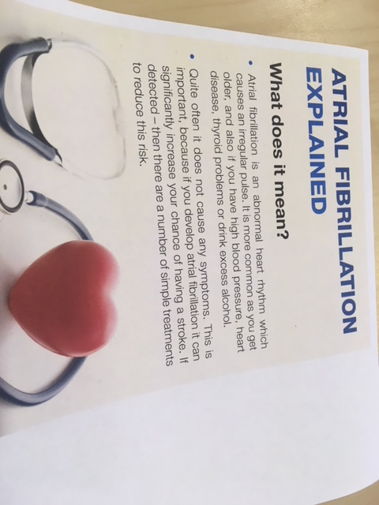

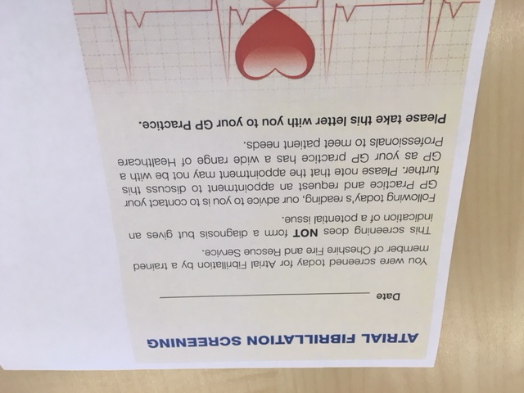

From July 2018, the heart rhythm checks will be offered to people aged 60+ as the results are more reliable in this age group.

We provide people with a 'Know Your Pulse' leaflet so that people can feel their own heart rhythm <http://www.heartrhythmalliance.org/aa/uk/know-your-pulse>